Application of Schrödinger's Wave Equation (1)
Let us consider an electron trapped in a 1-D potential well of length, L, with infinitely high barriers at each side.

Setting up the problem: If x<0 or x>L then V(x)= ∞. If 0≤x≤l then V(x)=0.
If the barriers are infinitely high then there is no possibility of the electron existing outside our potential well.
Thus at x=0 and x=L we can define boundary conditions that ψ=0 at these points, and we need to solve Schrödinger's Equation for the region where V(x)=0.
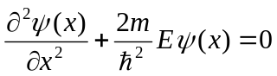
This equation can, by inspection, be seen to have a solution 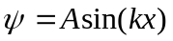, where 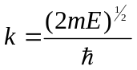
***EXERCISE*** Check this by substitution
The solution is is a standing wave therefore, given our boundary conditions, kx must be an integral number of π. This means k=nπ/L, where n is an integer.
We can therefore solve for the Energy levels: 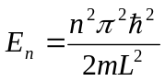
These are the energy levels that are allowed in our infinite potential well, where we have just obtained their wavefunctions and their energy states.
We can find the amplitude, A of the wavefunction by remembering that the probability funtion must equal one:
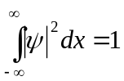
***EXERCISE*** Show that 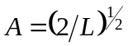
We can now draw the different wavefunctions and energy levels of the infinite well system we constructed:

This very simple example does have application in semiconductors in describing the behaviour of electrons in quantum wells. In a quantum well a narrower bandgap material is sandwiched between layer material of a wider bandgap. This traps the electrons and holes in the centre of the sandwich.

The advantages of quantum wells are that they are very efficient at emitting light and have application in quantum well lasers for example. Note we can also change the emission wavelength of the device by changing the quantum well width, L.
In the above example of course the barriers are not infinite, which means that we need a different set of boundary conditions to solve the equation. We will consider that in the next section.

Application of Schrödinger's Wave Equation (2)
If the barriers are non-infinite then the wavefunction at the edge of the well (at the well-barrier interface) cannot be zero. This means that there is some probability that the electron can exist outside the well (although, as we will see it will still most likely be in the vicinity of the well.
The more general boundary conditions are that at the barrier interface, where the potential suddenly changes, the wavefunction must be continuous and that the slope of the wavefunction must be continuous.
Mathermatically and 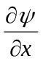must both be come to the same value as one approaches the inteface. The solution normally involves a sinusoidal central region with exponentially decaying tails into the barrier. The latter makes sense as we know the probabity of finding the electron somewhere must be 1. (finite number!), so as we tend to an infinite distance away from the well the wavefunction must tend to zero.

The Finite Barrier
Let us revisit the quantum well scenario again, but this time consider a well with finite barriers:
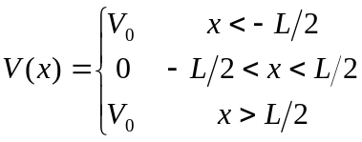

Call the regions I, II, III, respectively
Note we have set x=0 in the middle of the well.

Now as we have already indicated, our boundary conditions are that and 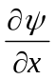must be continuous at the interfaces between the three regions. We can write this by saying at the interface between region I and II: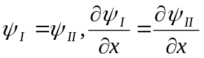.
In region II, we have V=0, so Schodingers equation reduces to: 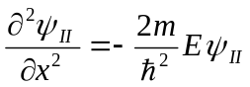
Setting 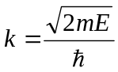 we can get 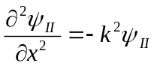
The general solution to this is 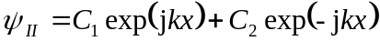.
And from the symmetry of the problem we have that 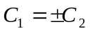(the probability must be the same for a particle travelling in either direction across the well)
If 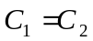then the solution will take the form of 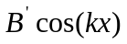, and if 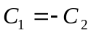then similarly the solution will be of the form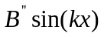.
In region I we have 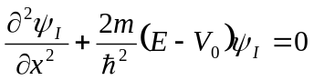
Setting 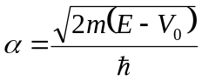we get 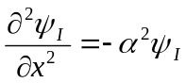
The general solution is 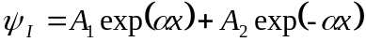
Now in region I we know that the solution must decay away as x becomes more negative and therefore in this case we can say that 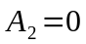.
We can apply a similar logic in region III to get 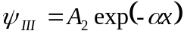.
And again from the symmetry of the example we can say 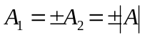.
We now have solutions to Schrodinger's Equation in each of the three regions of interest:
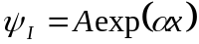, 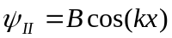(EVEN Solution) , 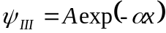
So we need to apply out continuity conditions at x=-L/2 and x=L/2.
At x=L/2 the continuity of gives 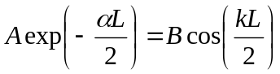
And the continuity of gives 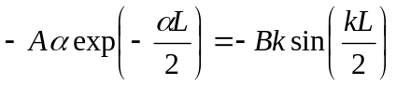
We can apply the boundary conditions similarly at x=-L/2. (HOMEWORK)
Divide the above two equations (at x=L/2): 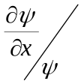gives 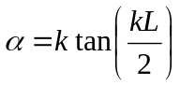
We can back substitute for 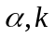to get 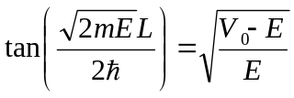
For the ODD solutions [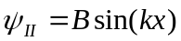] we similarly can get 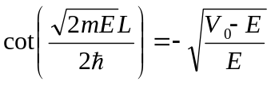
To see what these represent we will introduce new variables 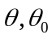
where 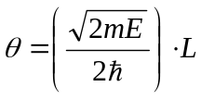 and 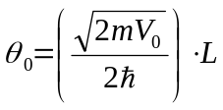
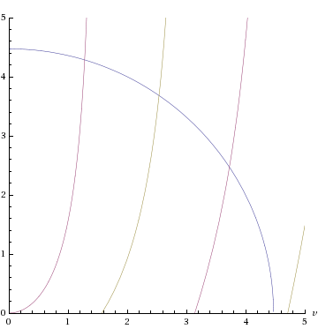
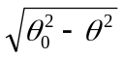For Even solutions we can show the equation above can become 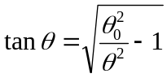 or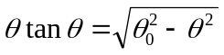.
Even:
It is easier to examine this function
graphically.
We can now plot this as shown
on the right
Odd:
Each intercept is an allowed
solution.
The key points are that there will
be
1. A finite number of levels in the
well
2. At least one confined state in the
potential well

